

**BLG 413E**

**SYSTEM PROGRAMMING**

CRN: 12300

**REPORT OF PROJECT #3**

Submission Date: 09.12.2014

**Members of Group #16:**

Mustafa UÇAR 040100113

Tuğrul YATAĞAN 040100117

Emre GÖKREM 040100124

**Demo Assistant:**

Gökhan SEÇİNTİ

# **Introduction**

In this project, a Linux character device driver that converts text data between various character encodings is developed. The following encodings are supported: UTF-8, UTF-16, UTF-32, ISO8859-1, ISO8859-9.

# **Compilation and Installation**

The module can be compiled and install with a script:

#!/bin/bash

make

rmmod scull

rm /dev/scull0

insmod ./scull.ko scull_quantum=4096

mknod /dev/scull0 c 250 0

Module compiled and installed without error. This script also makes device node.

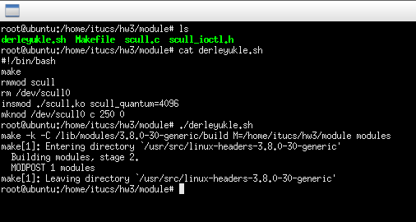

After installation, /dev/scull0 device can be seen in /dev directory also scull module can be seen in module list:

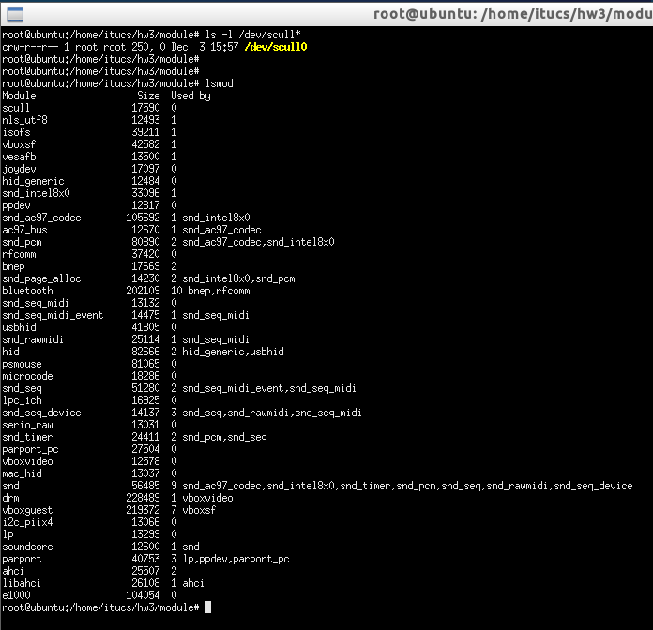

# **Running**

There are 3 test applications. These can be compiled as bellow.

* **writeread** for testing encoding conversation, read, write, ioctl and main attributes of device
* **seek** for testing seek ability of device
* **singleopen** for testing single open attributes of device

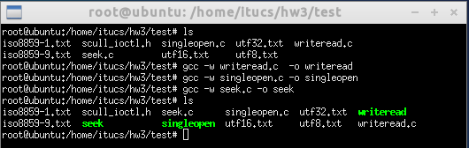

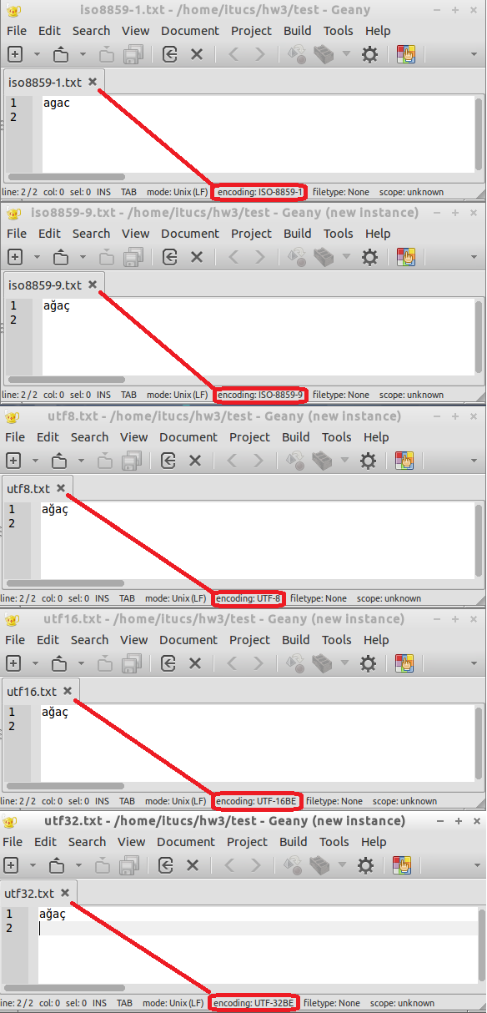

Prepared test encoding files are above. File names are given according to encodings.

Example run of **writeread** test program for converting encoding ISO8859-9 to UTF32:

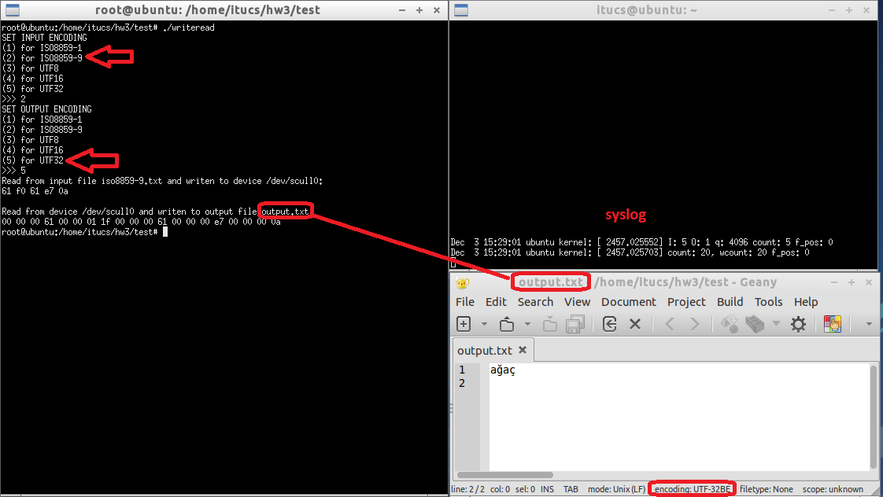

Example run of **writeread** test program for converting encoding ISO8859-9 to ISO8859-1, a special character (square) is put for unsufficient characters:

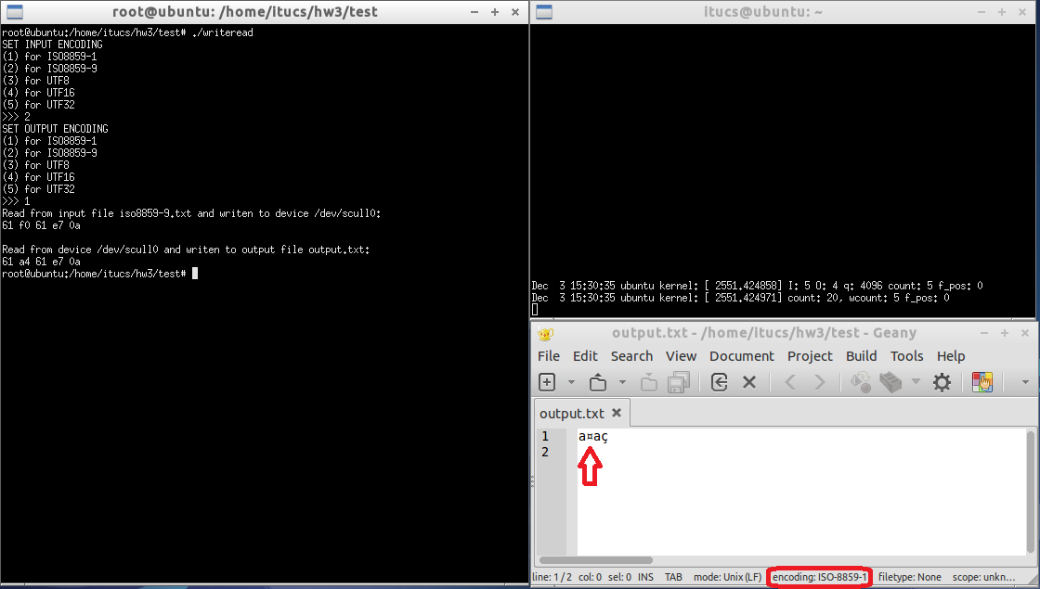

Example run of **writeread** test program for converting encoding ISO8859-9 to UTF8:

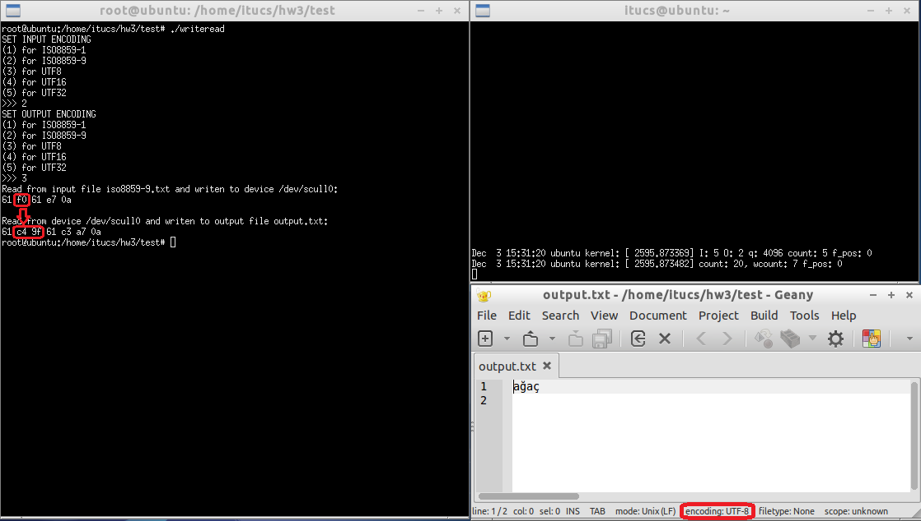

Example run of **singleopen** test program from different processes at the same time:

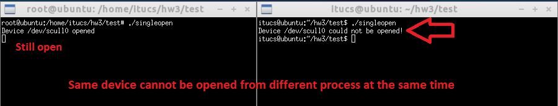

Example run of **seek** test program for seeking cursor at 6 and writes new data. So new string converts “ağaç” to “amaç”, ‘ğ’ is replaced with ‘m’:

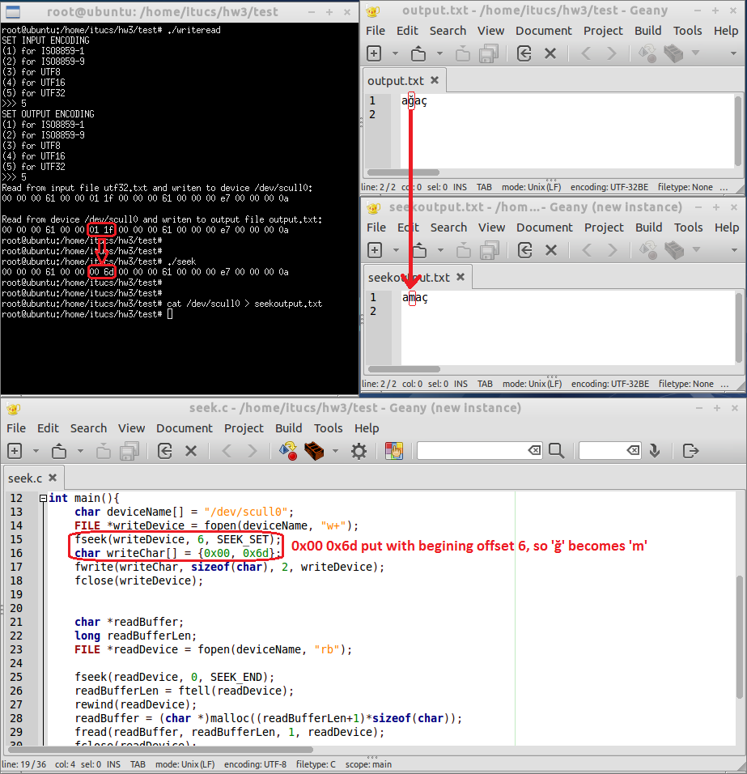

# **Code**